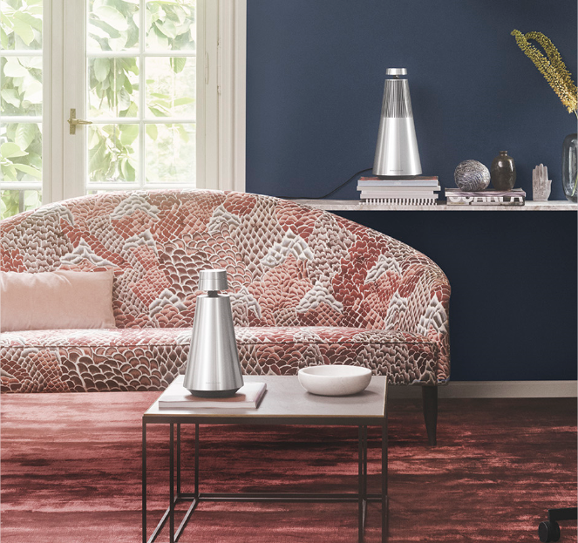

Introducing BeoSound 1 & 2:
Wireless speakers designed for flexible living

BeoSound 1 and BeoSound 2 are wireless speakers designed for convenience, crafted for mobility and featuring an impressive 360 degrees of spherical sound magic.

Struer, Denmark, August 31st, 2016

The only certainty in technology, perhaps also life, is that things change. We all live different lives, and the challenge we put to ourselves is to create products that are relevant in as many contexts as possible. The way that you live and work is more flexible and fluid than ever, and we adapt and cater to that.

BeoSound 1 and BeoSound 2 are Bang & Olufsen’s answer to an ever-changing everyday life; they are both ultra flexible in terms of usability, connectivity and placement options - and they deliver an unparalleled 360-degree sound experience no matter where the speakers or you are placed.

“We live in a time of cord cutting where everyone wants more freedom. No one wants to be hindered by technological restriction, says Marie Kristine Schmidt, Vice President Brand, Design & Marketing and continues, “BeoSound 1 & 2 is designed to cater for a flexible lifestyle where music blends naturally into the home. The design is unobtrusive yet powerful, underscoring the purpose of the speakers”.

Feel the groove
The sturdy yet elegant aluminium design profile of BeoSound 1 and 2 blends into any interior with a subtle touch of delicacy and ease. Place them wherever you want your music; on the shelf, casually on the floor, by the coffee table or even outdoors.

The conic bodies hover slightly above the ground, letting the thumps of the bass units out beneath. They are slightly open at the top for acoustical reasons, but apart from that with a uniform expression on the aluminium surface.

BeoSound 1 is a portable lightweight wireless speaker with a battery-driven option crafted for mobility. It has a small groove under the top to ensure a better grip when it’s lifted up and moved around.

BeoSound 2 is its slightly bigger and more powerful sibling. It needs a permanent power connection to produce its vigorous output of excellent sound with great clarity and distinction

360 degrees of advanced acoustics
BeoSound 1 and 2 are equipped with the Acoustic Lens Technology renowned from classic Bang & Olufsen speakers such as BeoLab 5 and BeoLab 18. The acoustic driver is placed in the top of the speakers, playing into a reflector that creates a spherical and powerful 360-degree sound experience.

Direct streaming of music
Multiple connectivity options such as Google Cast, AirPlay, DNLA and Bluetooth offer easy access from mobile devices and music apps. BeoSound 1 and 2 also provide integrated access to TuneIn Internet radio stations as well as Spotify and Deezer music services to allow streaming of music without using a smartphone or tablet.

Intuitive sensor technology
BeoSound 1 and 2 introduce a magical experience using proximity sensors that enable control of the basic operations on the speaker intuitively. As the sensor detects your presence, it is ready for commands with the user interface turned towards the user. Turn the wheel to adjust the volume, and simply swipe and tap on the top for other commands.

Music across the home
BeoSound 1 and 2 are the newest members of the Bang & Olufsen BeoLink Multiroom portfolio that connects your Bang & Olufsen products into one wireless music system across the home. Connect up to 8 BeoSound 1 and BeoSound 2 in a multiroom set-up.

BeoSound 1 is available in Bang & Olufsen stores now at a recommended retail price of DKK 9995/€1295/£995/US$1495. BeoSound 2 is available from end October 2016 at a recommended retail price of DKK 12.995/€1695/£1350/US$1895.

#BangOlufsen
#BeoSound1
#BeoSound2
#FlexibleLiving

For more information, please contact:
Tina Banzhaf, Sr. Global PR Manager
Bang & Olufsen Danmark a/s
Phone: +45 96 84 58 43
Email: tbf@bang-olufsen.dk

Bang & Olufsen was founded in Struer, Denmark, in 1925 by Peter Bang and Svend Olufsen, two innovative, young engineers devoted to high quality audio reproduction. Since then, the brand has become an icon of performance and design excellence through its long-standing craftsmanship tradition and the strongest possible commitment to high-tech research and development.

Still at the forefront of domestic technology, Bang & Olufsen has extended its comprehensive experience with integrated audio and video solutions for the home to other areas such as the hospitality and automotive industries in recent years. Consequently, its current product range epitomizes seamless media experiences in the home as well as in the car and on the move.
For more information on Bang & Olufsen, please visit www.bang-olufsen.com. Images are available free of charge from the Bang & Olufsen media centre: http://mediacenter.bang-olufsen.dk.

